Designee Overview: To add/delete/verify
- Click the “My Designee” tile to Add, Remove or Recertify/Verify your Designees
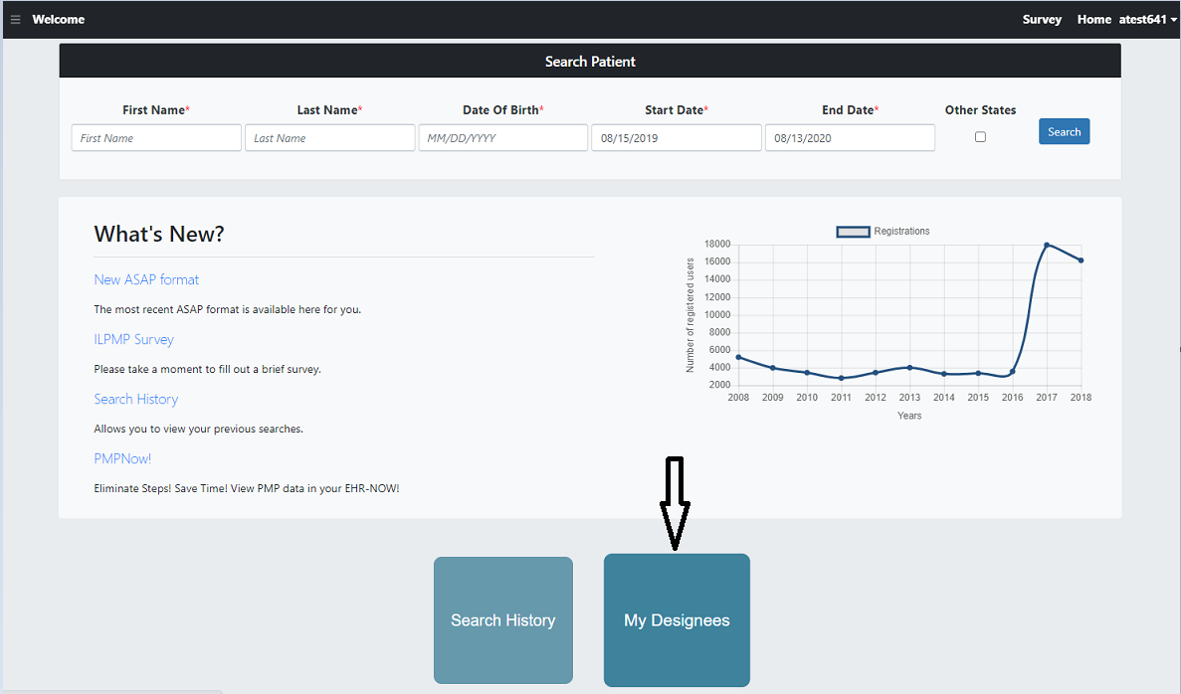

- Add Designee:
- To add a designee, enter their license number and click “Add”. Only 3 designees are allowed at a time.
- To successfully add a designee the given license number should be registered as a designee to ILPMP.
- Designees can only be on one designees list.
- Once a designee is successfully added, supervisor and the designee will receive an email confirmation.
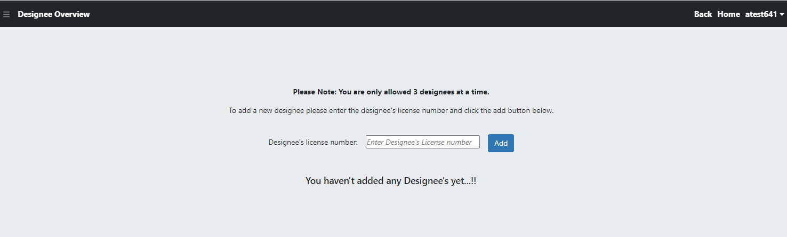

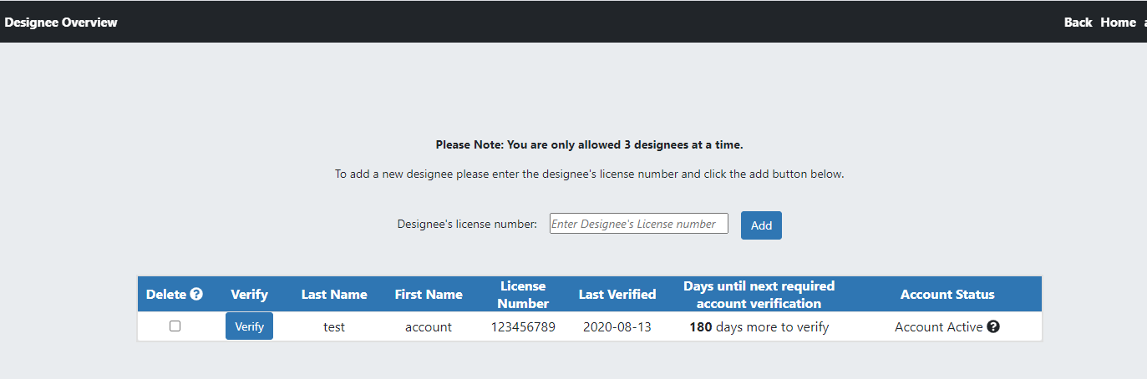

- Remove designee
- To remove a designee from your account, check the “Delete” checkbox that is attributed to their name. Then click on the delete button. Then a pop-up window will be displayed with the message. Please remove individuals who no longer work with you.
- Once designee is successfully deleted, supervisor and the designee will receive an email confirmation.
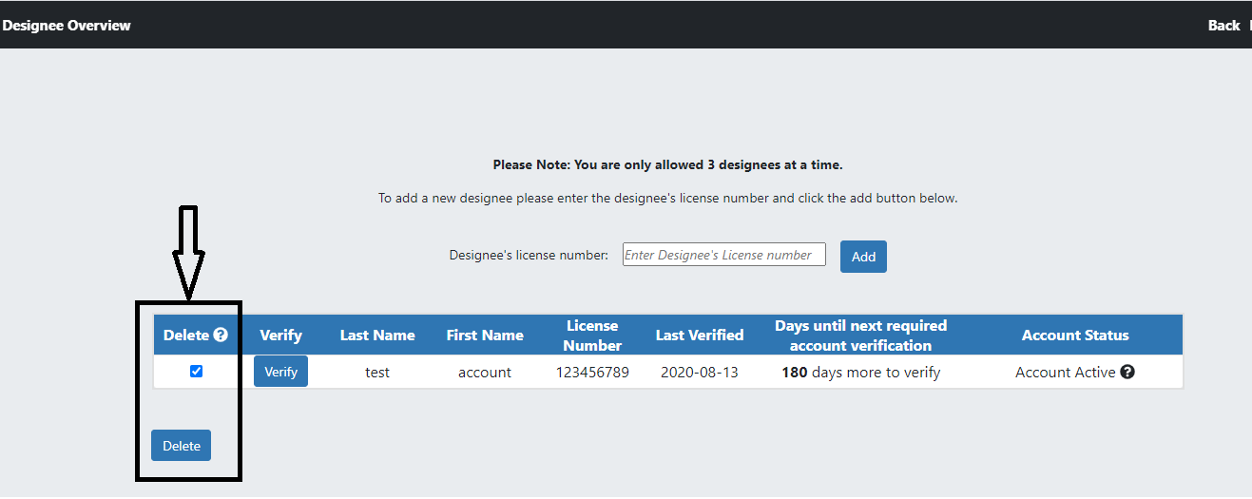
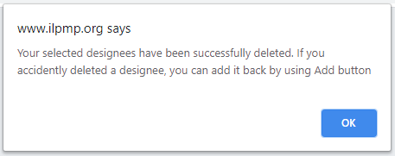

- Verify/Recertify designee:
- Any searches done by the designee is attributed to their supervisor. For this reason, supervisor is responsible for their designee’s searches.
- To check what has been searched by your designee click the “Verify” button. Designee accounts must have their account verified/recertified every 180 days.

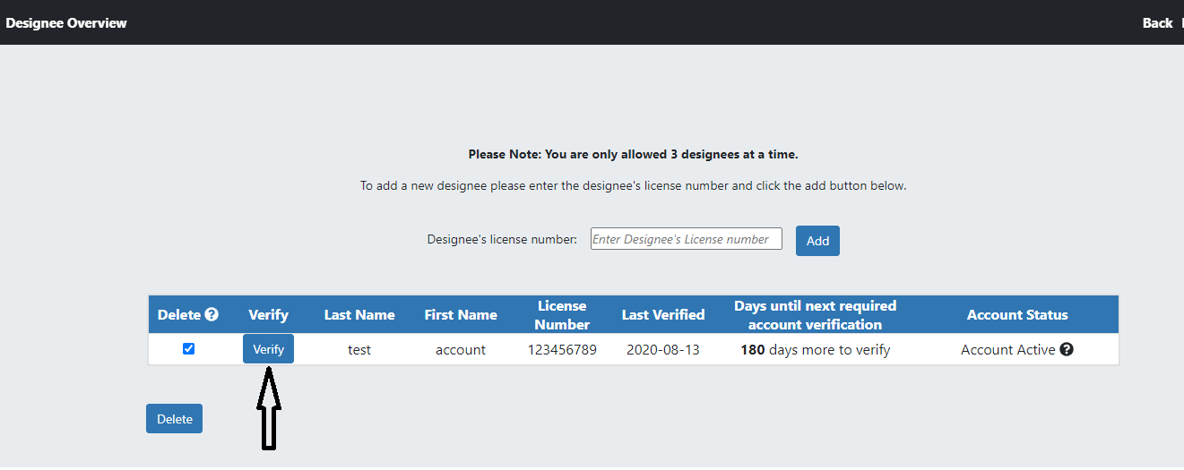

- The next page will show what searches have been made by the designee

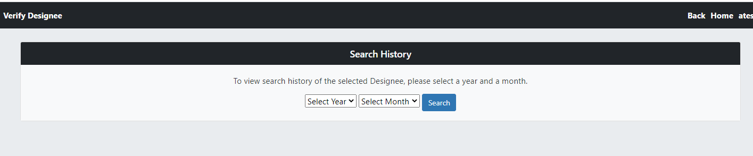
- Select the year and month for which you wish to view the search history of your designee. Click the “Search”, it will appear as follow
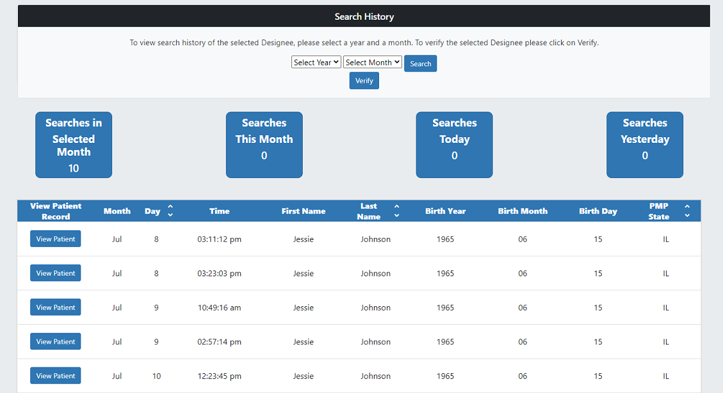

- If no searches were made during the year and month selected, it will appear as the following:

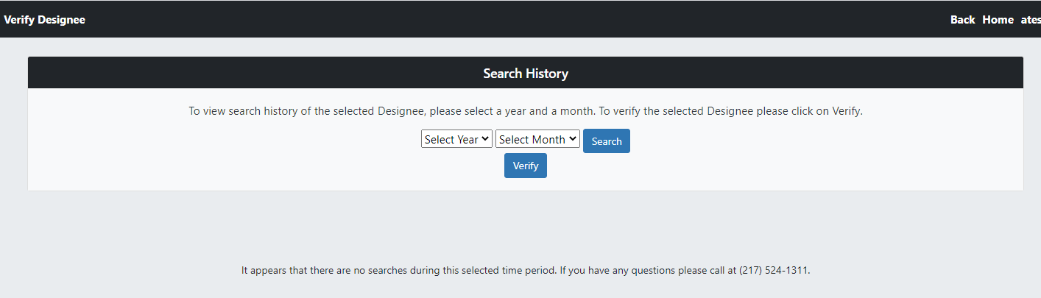

- After couple of Searches “Verify” button will be displayed. click on “Verify” button to verify/recertify the designee. Then a pop-up window will be displayed with the message.
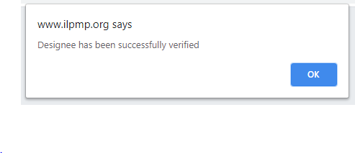
- Designees can potentially lose the ability to make Patient Searches on PMP due to:
- The designee in question has not been added as a designee by their supervisor in the PMP.
- PMP listed supervisor has not verified the Designee’s searches in more than 6 months.

My Supervisors:
- Designee’s can check their supervisors by clicking on “My Supervisors” tile on welcome page.
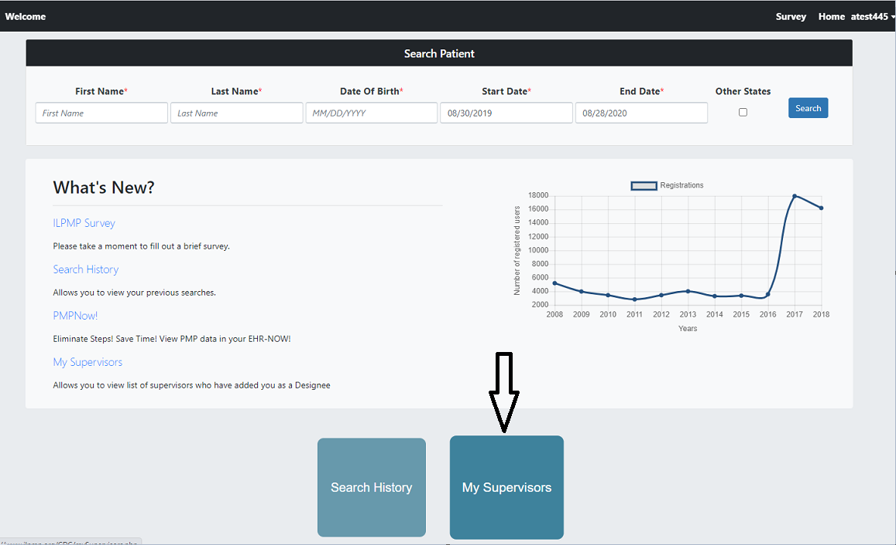
- Here is how supervisor’s information is displayed.
- Designee’s can only view their supervisor’s information, no changes can be made by designee.

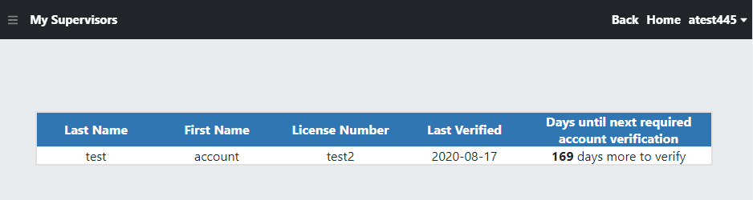

- A registered Designee is only authorized to make Patient Searches if they have been added and verified as a designee by their Supervisor. If they have not been authorized then the following message will be displayed on designee’s welcome page.

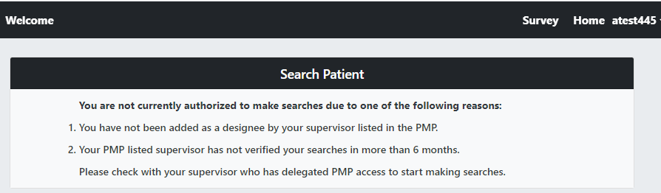

- Designee’s must contact their supervisors regarding any account changes such as the ability to add a designee, delete a designee or verify a designee.

